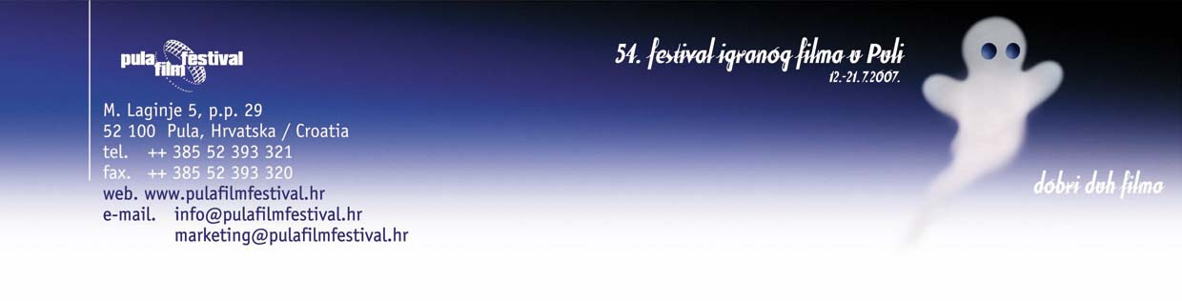

Awards of the 54th Pula Film Festival

The Jury of the National competition programme composed of:
Arsen Anton Ostojić, president

Branko Linta, member
Tonko Lonza, member
Diana Nenadić, member
Tamara Obrovac, member

has granted following awards:

- Big Golden Arena for best film to THE LIVING AND THE DEAD by Kristijan Milić
- Golden Arena for directing to Kristijan Milić for THE LIVING AND THE DEAD
3. Golden Arena for screenplay to Ognjen Sviličić for ARMIN by Ognjen Sviličić
- Golden Arena for best female leading role to Nataša Dorčić for I HAVE TO SLEEP, MY ANGEL by Dejan Aćimović
- Golden Arena for best supporting role to Olga Pakalović for I HAVE TO SLEEP, MY ANGEL by Dejan Aćimović
- Golden Arena for best male leading role to Emir Hadžihafizbegović for ARMIN by Ognjen Sviličić
- Golden Arena for best male supproting role to Borko Perić for THE LIVING AND THE DEAD by Kristijan Milić
- Golden Arena for cinematography to Dragan Marković and Mirko Pivčević for THE LIVING AND THE DEAD by Kristijan Milić
- Golden Arena for editing to Goran Guberović (posthumously) for THE LIVING AND THE DEAD by Kristijan Milić
- Golden Arena for music to Andrija Milić for THE LIVING AND THE DEAD by Kristijan Milić

- Golden Arena for screenplay to Tanja Lacko for PLAY ME A LOVE SONG by Goran Kulenović
- Golden Arena for costume design to Sanja Šeler for PLAY ME A LOVE SONG by Goran Kulenović
- Special Golden Arena for special effects to Goran Rukavina and Branko Repalust for THE LIVING AND THE DEAD by Kristijan Milić
- Special Golden Arena for sound to Ivica Drnić, a designer, Damir Valinčić and Igor Fabris, camera fro THE LIVING AND THE DEAD by Kristijan Milić
- Vjesnik's Breza award for best debutant to Livio Morosin for music in I HAVE TO SPEEP, MY ANGEL by Dejan Aćimović

Jury of the International competition programme composed of:
Eva Zaoralova, president
Annamaria Percavassi, member
Serge Sobczynski, member
Roland Rust, member
Phillip Bergson, member

has granted following awards:
- Special Golden Arena for artistic achievement to LOVE SONGS by Cristophe Honoré
- Special Golden Arena for best directing to Jiří Menzel for I SERVED THE KING OF ENGLAND
- Special Golden Arena for best film form the International competition programme to SALT AIR by Alessandro Angelini

The Jury of young film lovers has granted following awards:
- Award of the young film lovers' Jury for best International competition programme film to I SERVED THE KING OF ENGLAND by Jiří Menzel
- Award of the young film lover's Jury for best film from the National competition programme to I HAVE TO SLEEP, MY ANGEL by Dejan Aćimović

Arena audience jury
The Arena audience has awarded THE GOLDEN GATE OF PULA to PLAY ME A LOVE SONG by Goran Kulenović

